**Oriental Veggie Stir-Fry**

Ingredients:

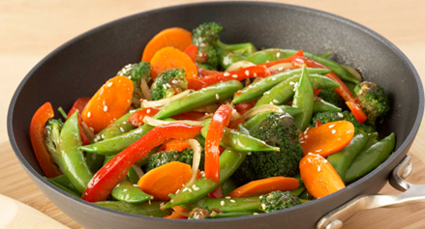2 stalks of celery, diced

1 medium carrot, julienned

1 bell pepper, chopped or sliced

1 head of broccoli, broken into small pieces

For Sauce:

1 tbsp. brown sugar

1 tbsp. soy sauce or amino acids

1/2 tbsp. vinegar (balsamic preferred or other varieties)

1 tsp. sesame oil

1 Tsp. sesame seeds

1/2 tbsp. flour

1/8 tsp. ground ginger

Dash of red pepper flakes (or sub 1/4 tsp. hot sauce...or more if you like heat!)

Directions:

1. Wash and cut vegetables as directed. Set aside.
2. Make stir-fry sauce. Whisk all ingredients together in a small bowl.
3. Place vegetables in a wok or frying pan large enough to fit everything. Pour over vegetables while frying. Stir-fry vegetables until crisp-tender. Check with a fork!
4. Once finished, let cool in saucepan for 1 minute. Remove from heat and serve.