**Teacher/ Student Contract- OJRHS**

In this course, you will put your background knowledge about children into action, provided with a “hands on” experience working with preschool age children. A laboratory preschool is conducted within the second month of the course. You will be responsible for the development of the preschool, its daily maintenance, and planning activities. Not only will we be further investigating the development of young children, but the emphasis will be on creating stimulating lessons and activities for young children, acting as a preschool teacher.

**Course Content**

Unit 1: Teaching Basics- (Week 1/2)

* 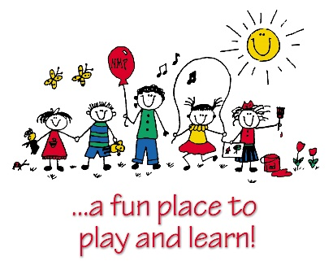Favorite Teacher
* Qualities of an Effective Teacher
* DAP Guidelines and Preschool Standards
* Safety
* Behavior Concerns

Unit 2: Lesson Planning (2 weeks before preschool opens)

* What goes into an effective lesson plan?
* What are learning objectives?
* Observing Children

Unit 3: Language arts and Literacy Lessons (2 weeks)

Unit 4: Math and Logic Lessons (2 weeks)

Unit 5: Fine Arts/Enhancing Creativity Lessons (2 weeks)

Unit 6: Music and Movement Lessons (2 weeks)

Unit 7: World Language Lessons (1 week)

Unit 8: Social Studies/Science Lessons (2 weeks)

Unit 9: Quality Education (last month of the semester)

* How do I choose the best preschool/daycare for my child?
* Field Trip (possible) to childcare facility

As a ***student*** in my class, it is your duty to:

1. Bring a POSITIVE and eager attitude to class every day.
2. Arrive to class on time and remain **seated** until the bell rings. (Lateness will be recorded.)
3. Be ready and PREPARED to learn. Please bring a pencil or writing instrument to class EVERYDAY. ALWAYS put your name on all assignments.
4. Be respectful and courteous to fellow classmates and their possessions.
5. Make up all projects/assignments within a timely basis when absent.
6. NO CELL PHONES unless approved by ME! I have the right to confiscate your phone at any time (and it will not be given back until the end of the class period.) **Note, on preschool lab days, participation points will be taken off for cell phone usage.**
7. Be SERIOUS. You will be working with children and parents from the community; therefore, how you portray yourself is very important. Immaturity WILL NOT be tolerated.
8. Lastly, remember that you are in a learning environment. Fooling around and disrespectful behavior WILL NOT BE tolerated and will result in the following:
9. First offense- Verbal warning
10. Second offense- Second verbal warning/parent contact
11. Third offense- detention

Grades:

1. Points will be earned through:

* In-class assignments (20%)
* Participation (20%)
* Projects (30%)
* Performance (10%)
* Homework (10%)

1. All points missed due to absence must be made up within 2 weeks or a zero will be given. Late work will be accepted, however points will be deducted from grade each day assignment is late.

After reading the student/teacher contract, please sign and return the following by: _________________________________

Name (printed): ______________________________________________

Student Signature: ____________________________________________

Parent Signature: _____________________________________________

After reading the student/teacher contract, please sign and return the following by: _________________________________

Name (printed): ______________________________________________

Student Signature: ____________________________________________

Parent Signature: _____________________________________________

After reading the student/teacher contract, please sign and return the following by: _________________________________

Name (printed): ______________________________________________

Student Signature: ____________________________________________

Parent Signature: _____________________________________________

After reading the student/teacher contract, please sign and return the following by: _________________________________

Name (printed): ______________________________________________

Student Signature: ____________________________________________

Parent Signature: _____________________________________________