Homemade Funfetti Cake

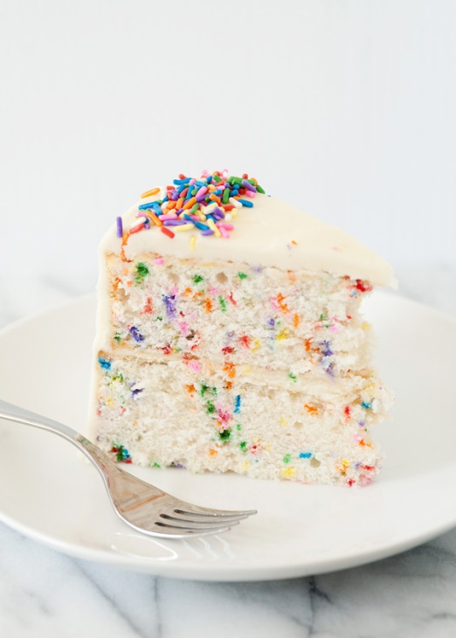**Ingredients:**

**Cake**  
1 cup all-purpose flour  
3/4 cup granulated sugar  
2 teaspoons baking powder  
pinch salt or 1/8 tsp.   
1 large egg  
1/2 cup buttermilk (1/2 cup milk with ½ Tbsp. vinegar- let sit for 5 mins.)  
1/3 cup sour cream  
1/4 cup canola or vegetable oil  
2 teaspoons vanilla extract  
1/4 cup sprinkles, or to taste

**Vanilla Buttercream Frosting (optional)**  
1/4 cup unsalted butter, ½ stick softened  
1 teaspoons vanilla extract  
pinch salt, optional and to taste (helps offset the sweetness)  
1 cup confectioners' sugar   
3 Tbsp. sprinkles

**Directions:**

1. Preheat oven to 350F. Grease an 8-by-8-inch baking pan with vegetable spray, set aside. For microwave cake, use a microwave safe pan.
2. **Cake -** In a large bowl, whisk together flour, granulated sugar, baking powder, optional salt; set aside.
3. In a separate small bowl, whisk together the egg, buttermilk, sour cream, oil, and vanilla.
4. Add the wet mixture to the dry, mixing lightly with a spoon or folding with a spatula until just combined. Small lumps will be present, don't overmix or try to stir them smooth.
5. Gently stir in the sprinkles, taking care not to overmix or they could bleed.
6. FOR MICROWAVE: Pour batter into a microwave safe pan. Bake in microwave for 2-3 minutes at a time, checking for doneness with a tooth pick after each segment. Cool for 10 minutes when complete.
7. FOR OVEN: Pour batter into prepared pan. Bake at 350 degree for 25 minutes. Cool in pan for 10 minutes, then turn out and cool completely.
8. Ice with frosting.

Instructions for Frosting

1. Cream the butter until it is light and fluffy. Add vanilla, salt and sugar. Whip for 2 minutes. Then, fold in sprinkles for about 20 seconds on low speed.

Complete the following questions after completing the lab (1 per group):

1. What is the difference between the 2 cakes? Please fill out the chart below with what you observed:

|  |  |  |
| --- | --- | --- |
|  | Microwave Cake | Oven Cake |
| Color |  |  |
| Texture |  |  |
| Taste |  |  |

1. Did the microwave cake ever caramelize (or turn brown)? Why is it likely not possible for the microwave cake to caramelize?