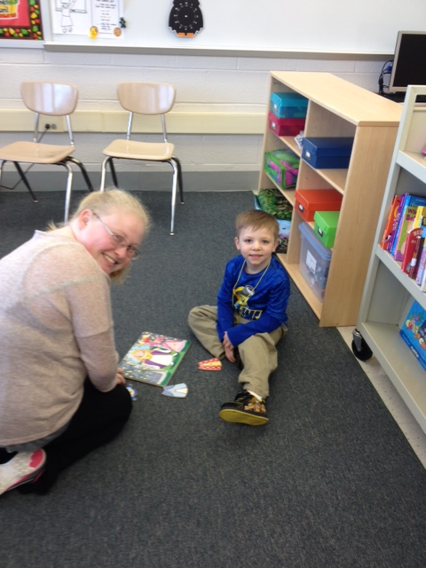  Dates of Operation 2017:  February 21,22, 23  February 28, (March 1, 2- closed for PT conferences)  March 7, 8, 9  March 14, 15, 16  March 21, 22, 23  March 28, 29, 30  April 4, 5, 6  April 18, 19, 20  April 25, 26, 27  May 2, 3, 4  May 9, 10, 11  May 16, 17, 18 (May 18- graduation) |  |  | Attendance Procedures  The Wee Wildcat Preschool Program will function on days Owen J. Roberts High school is in session. Please arrive promptly.  Weather Emergencies, Delayed Openings, & Early Dismissals  School closings will be announced through local news programs and listed on the Owen J. Roberts School district website: www.ojrsd.com/  If there is a delayed opening at the high school, on the day when your child is to come to preschool, we will cancel the preschool session for that day.  If for any reason Owen J. Roberts High School dismisses early, parents will be notified as soon as possible. If parents are not available, a person on the Emergency Information Sheet will be contacted to come for the child. |  |  |   - Laboratory Preschool  Owen J. Roberts High School  981 Ridge Road  Pottstown, PA 19465  Phone: 610-469-5101  Contact us:  Lindsay Hale  Owen J. Roberts High School  981 Ridge Road  Pottstown, PA 19465  Phone: 610-469-5101  Email: lhale@ojrsd.com (preferred)  Visit: http://www.ojrsd.com/Page/5909 for more information  

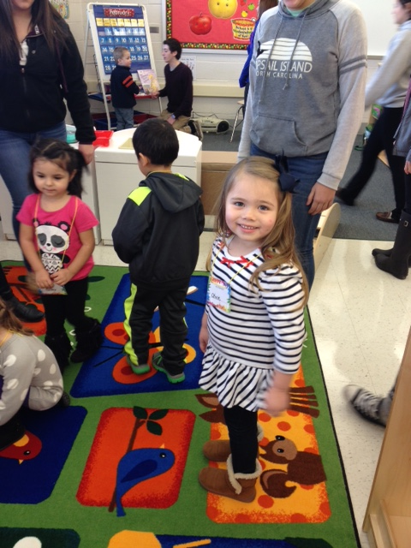  About Us  The Wee Wildcats Preschool Program is operated in conjunction with the Preschool Lab experience class offered by the Family and Consumer Sciences Department at Owen J. Roberts High School. It provides an opportunity for high school students to reinforce learning through observation and direct contact with young children under teacher supervision.  Our preschool program is designed to foster early independence and curiosity through the use of developmentally appropriate practices. Children learn through play and hands-on experiences in a safe and stimulating learning environment. |  |  | Important Information:  The preschool program for the 2016-2017 school year will run February to May 2017.  •10-12 children are selected to participate in the preschool program.  •The preschool day is 1 1/2 hours long. •The cost is $100.00 for a 12 week, 34  day session program running Tuesday, Wednesday and Thursday mornings from 8:30-10:00.  •Enrollment begins May 1, 2016 and  follows as a first-come first-serve basis.  The program is designed to  accommodate 3 ½ to 5 year-old children who:  - Are potty-trained  - Have had a physical examination made by a licensed physician at  least 6 months prior to  registration and acceptance  into the program.  - Are covered by a school or family insurance company acceptable by the Owen J. Roberts School District.  - Are socially adaptable and can communicate to express their  needs.  - Have parents/guardians who  are able to drop off and pick up their child within the dates and  timeframes provided. |  |  | The Wee Wildcat Preschool program offers an optimal first school experience. Children will be able to increase their social skills and engage in a program that offers a wide variety of activities that will prepare them for elementary school. Children will participate in:  - Circle Time, story time  - Free Play  - Thematic based lessons  - Snack time  - Math and Science activities  - Music and movement activities  Registration:  Registration begins May 1, 2016. Registration is made by filling out the Registration Form and returning it to:  Owen J. Roberts High School  Lindsay Hale, Preschool Director  981 Ridge Road  Pottstown, PA 19465  Attn: Preschool Registration  Contact Us:  Lindsay Hale  Owen J. Roberts High School  981 Ridge Road  Pottstown, PA 19465  Phone: 610-469-5101  lhale@ojrsd.com (preferred)  Visit us on the Web:  [Web Address]

