**[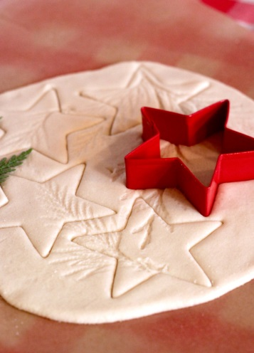](http://mystudiobellingham.files.wordpress.com/2011/12/img_67161.jpg)Salt Dough Ornaments**

•1/2 cup regular table salt

•1 cup white flour

•1/2 cup luke warm water

1. Combine all ingredients in a bowl, form a dough and then turn out to knead… work it for about 5 mins., the longer you do it the smoother it will get.
2. Roll out to desired thickness. Use cookie cutters to achieve desired shape. Stamp with tree leaves if desired. Use a straw or tooth pick to punch a hole on one part of the ornament. Move to an ungreased cookie sheet.
3. Bake on a low temp (200 degrees) for about 30 minutes to an hour to get the drying process started. Move onto a cooling rack. Baking them will curl the edges when thin and may or may not change the color of the dough.