“Build Your Own” Whole Wheat Pancakes

Minutes to Prepare: *25* Number of Servings: *6-8 (1 pancake)*

Ingredients:

* [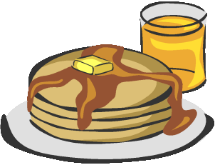](http://www.google.com/url?sa=i&rct=j&q=&esrc=s&frm=1&source=images&cd=&cad=rja&uact=8&docid=RjN8bcphjq1_kM&tbnid=fCj1RAt_nsod2M:&ved=0CAUQjRw&url=http://stclareroseville.org/index.cfm?load=event&event=133&ei=2fUdU72sCoLl0wGL0IGgDA&bvm=bv.62578216,d.dmQ&psig=AFQjCNGHu90g9pKzKCny3iOONkaQ90MuEw&ust=1394558798956046)1 cup whole wheat flour
* 1 cup + 1 Tbsp. milk
* 1 egg
* 2 ¼ tsp. baking powder
* 1 tsp. cinnamon (optional)
* 1 tsp. sugar
* 1 tsp. vanilla
* ¼ tsp. salt
* Optional Toppings: chocolate chips, syrup, butter

Directions:

1. Combine all **dry** ingredients including flour, baking powder, cinnamon, sugar, and salt into medium mixing bowl.
2. Add **wet** ingredients to dry ingredients in the mixing bowl one at a time (milk, egg and vanilla). Lightly mix with a whisk just until flour disappears.
3. Preheat griddle by placing onto stovetop and turning on to medium heat. Check for readiness by sprinkling a drop of water on griddle; it should sizzle.
4. Spray griddle with cooking spray.
5. Spoon about 2-3 tablespoons of batter on griddle. Let sit for 30 seconds. When edges start to bubble, flip over with a spatula. After another 30 seconds, flip onto a clean plate. Repeat with remainder of batter.
6. Serve; Choose toppings individually.
7. Set griddle aside and let cool when finished serving. **\*\*DO NOT WASH- it is hot!\*\***