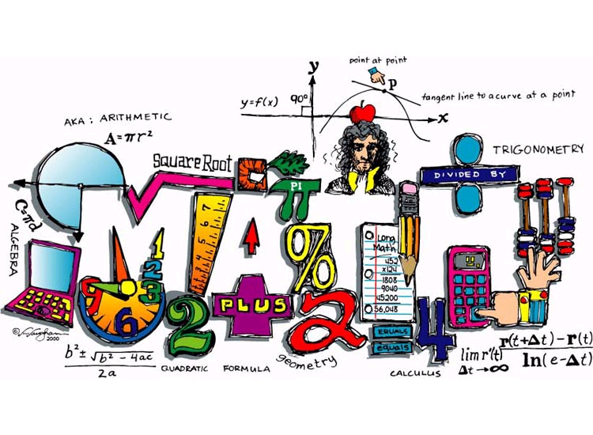

**EDM Math Check List**

*Use these steps for each problem you do!*

*Do not turn in your work if you have not used this guide/process for each problem*.

For **EACH** problem:

____ **Decide what the problem is asking you to find**; in other words

what will your answer tell you/me. (e.g. amount for one item, the total

cost, the average of some numbers, how many groups or items, etc.).

**Make sure you can verbally answer the question to yourself.

____ **Write neatly**. ***Erase*** completely, no write overs unless they look like

you never made a mistake***. Line up*** your numbers.

____ **Check your work**, ***do not move onto the next problem until you***

***have checked:***

|  |  |
| --- | --- |
| **Check** | **With** |
| Division | Multiplication |
| Subtraction | Addition |
| Addition | Re-add (try starting at bottom if you originally started at the top) |
| Multiplication | Re-multiply; be careful of your carrying |

_____ ***Does your answer make sense?*** Is it too high? Too low? Are your decimals in the right place?

_____ ***Did you really answer the question/problem given?*** Go back and check item #1 on this list.

_____ ***Box or otherwise mark your answer clearly to indicate that it is the final answer.***

If given word problems, give your answer in a complete sentence. Read over your sentence aloud and check punctuation, spelling, and grammar, etc.

**In your answer:**

____ Did you need to write any **units** in your answer?

____ Did you need to write any money **symbols** or signs in your answer?

____ Is your answer in simplest form?