Name _________________

# AP Biology Summer Assignment

**Directions:**

* Over the summer you will be responsible for viewing several videos and answering a series of questions. This should only take you several hours to complete.
* 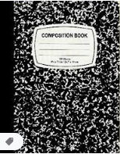This assignment will be due the end of our first week of school (before you leave for the long Labor day weekend).
* Make sure to bring a marble notebook to class the first day of school for your lab notebook

**Video 1: Data Collection**

[www.bozemanscience.com/apb-practice-4-data-collection-strategies](http://www.bozemanscience.com/apb-practice-4-data-collection-strategies)

1. What is science? Diagram his flow chart (you can do it left to right): The belief that:

2. In addition to collecting data you have to be able to:

3. Questions in four areas:

a. To _____________________ Data Collection Strategies. See if you can guess the

right answer to the photosynthesis question BEFORE he explains it. You can see how

he justified his answer. Did you get it right? ______

b. To ________________ a plan for ________________ Data of your own

i. First you would need to:

ii. Then: ____________ an experiment that

What would a good essay contain?:

c. To ________________ to

d. To ________________ ________________ of Data.

4. What makes science, science?

**Video 2: Populations**

[www.bozemanscience.com/050-populations](http://www.bozemanscience.com/050-populations)

1. Define symbiosis:

2. Explain the relationship(s) between the clown fish and the sea anemone/algae?

3. The Symbiosis can ______________ or _______________ an ecosystem.

4. Ecosystems are kept in check by:

5. If they are not in check a ___________________ can happen.

6. Fill in the matrix of Interactions:

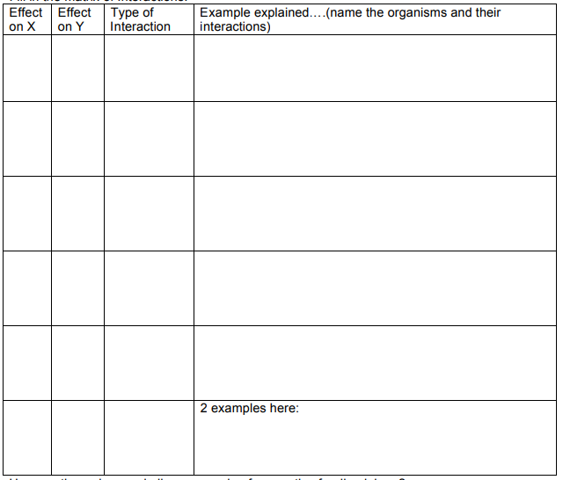

7. How are the wolves and elk an example of a negative feedback loop?

8. Kudzu, once introduced into a new ecosystem, is unstoppable until now…what has

happened?

**Video 3: Communities**

[www.bozemanscience.com/046-communities](http://www.bozemanscience.com/046-communities)

1. What does BBECPO stand for?

2. What is community structure built on? (2x)

3. What is the key term for community interactions?

4. Growth: all populations start with what type of growth?

5. What is a community made of?

6. What is symbiosis and what are the three types?

7. Explain the Leaf-Cutter ant symbiotic relationship with the fungus

8. Concerning population growth: what are the two limiting factors and examples for each?

9. What is the carrying capacity?

10. Draw a simple age-structure diagram:

11. What happens when most of the population is very young?

12. How is the United State’s age-structure diagram different from Angola’s?

**Video 4 – Ecosystems**

[www.bozemanscience.com/047-ecosystems](http://www.bozemanscience.com/047-ecosystems)

1. What is an ecosystem?

2. What is primary productivity?

3. Name and describe the two impacts on an ecosystem.

4. Humans often times make changes, that are quick and can lead to:

5. What are producers?

6. What do we measure primary productivity in? (units)

7. How is carbon added?

8. How is primary productivity measured in an aquatic environment?

9. What do food chains measure?

10. What is a trophic level? And what is Level 1? 2? 3? 4?

11. Define consumer

12. Which way do the arrows go in a food chain?....and how can you remember?

13. What does a food web show?

14. Each organism has an _____________________ to live where they are.

15. Initially, all growth is:

16. As you grow, there start to be ________________ factors. Name the two.

17. All growth, eventually become _____________________

18. What is “K”?

19. Describe what happened in Yellowstone Park with the introduction of the wolves? (Just the

wolf population)

20. How does the wolf population relate to the elk population?

21. Example of man’s impact on an ecosystem:

a. Whitebark Pine produces:

b. _______________ feed on them. The nuts are stored in _____________

c. Grizzly bears ____________ the abandoned middens.