**Microscope: Label The Parts**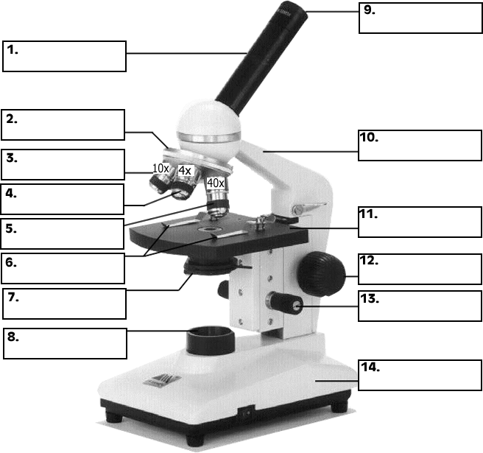

Light

Base

Fine Adjustment

Coarse Adj. Knob

Stage

Stage Clips

Arm

Diaphragm

High Objective Lens

Med Power Obj Lens

Low Power Obj. Lens

Nosepiece

Body Tube

Eyepiece