**Double Chocolate Brownies**

Ingredients

* 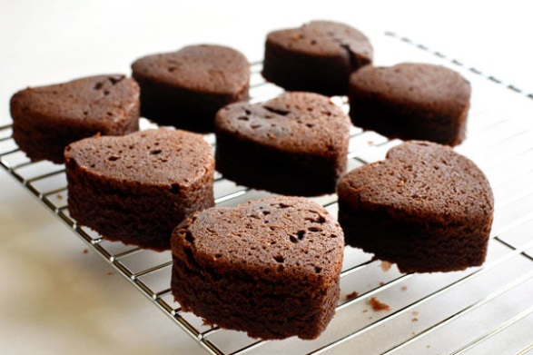1 cup (2 sticks) butter
* 2 1/4 cups granulated sugar
* 1 1/4 cups cocoa powder
* 1 tsp. salt
* 1 tsp. baking powder
* 1 tbs. vanilla extract
* 4 eggs
* 1 1/2 cups flour
* 2 cups semi-sweet chocolate chips

Instructions

1. Preheat oven to 350º F. Lightly grease a 9 x 13 inch baking pan with cooking spray; set aside.

3. In a medium saucepan melt butter over low heat.

4. Once butter is completely melted add in sugar and cook for 1 to 2 minutes, stirring constantly. Pour sugar mixture into a large bowl.

5. Crack eggs in custard cup. Beat in cocoa, salt, baking powder, vanilla, eggs. Mix until combined.

7. Stir in the flour and chocolate chips until well combined.

8. Spread brownie batter into prepared pan (batter will be very thick).

9. Bake for approximately 30 minutes.

10. Cool on a cooling rack and enjoy!

**Double Chocolate Brownies**

Demonstration Handout

1. What is the first thing to do to the oven when beginning this lab? What temperature?
2. Explain in detail how to measure 1 cup of flour accurately.

*

*

1. Why do you have to be extremely careful when melting butter on the stove?
2. Granulated sugar (white) simply needs to be leveled off to be an accurate measurement, but how do you get an accurate measurement of brown sugar if using that instead?
3. When measuring liquid ingredients, be sure to keep the measuring cup on a ________ surface and not held in the air.
4. Why is a custard cup or separate container used to break an egg into?
5. What is the difference between baking soda and baking powder?