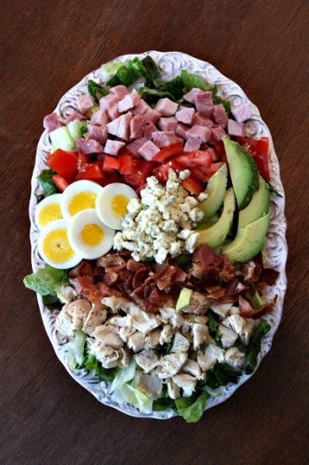**NEW AGE COBB SALAD**

**INGREDIENTS:**

1 head Romaine lettuce, chopped

1/2cup julienned, cooked chicken

1/3 cup Cheddar cheese shreds

3 strips bacon, cooked and crumbled

2 hard-boiled eggs, sliced

1 avocado, peeled, pitted and sliced

1 medium tomatoes, diced

2 Tablespoons fresh basil (chiffonade)

Croutons (optional) and dressing of choice

1 Tablespoon minced garlic (optional)

**DIRECTIONS:**

1. First, cook hard boiled eggs and bacon on the stove top. For hard-boiled eggs, fill a medium saucepan 3/4 full of water. Carefully drop eggs inside. Bring to a boil. Let the eggs sit in the boiling water for 20 minutes, then drain, rinse and let them cool before peeling and slicing.
2. To make bacon, place slices onto a saucepan (ungreased) and cook on medium heat for about 5-6 minutes.
3. For presentation, choose a large serving dish or bowl. Spread out lettuce evenly.
4. Layer the remaining ingredients into rows, dividing between each. Serve with dressing on the side. You may also add croutons.