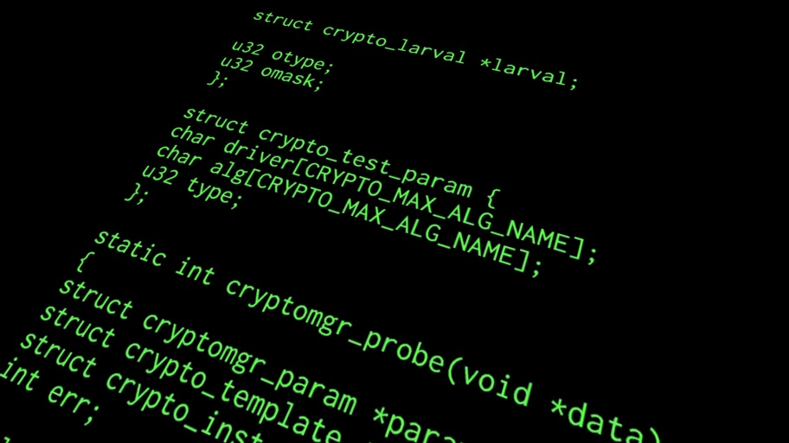Interested in

Coding & Animation?

Animation Programs:

* <https://www.nyfa.edu/student-resources/best-free-open-source-animation-software/>
* <https://www.moovly.com/>
* <http://wideo.co/en/>



**Coding sites:**

* <https://Code.org>
* <https://www.tynker.com/hour-of-code/>
* <https://www.khanacademy.org/hourofcode>
* <https://www.gethopscotch.com/hour-of-code>
* <https://www.kodable.com/>
* <https://www.commonsensemedia.org/blog/cool-tools-to-help-kids-learn-to-code>

**These links are on my school wires webpage – under class links – called “Animation and Coding.”**