Homemade Nanaimo Bars (Canadian Classic)

Prep time: 1 hour Total time: 1 hour Serves: 10

**Ingredients**

BASE:

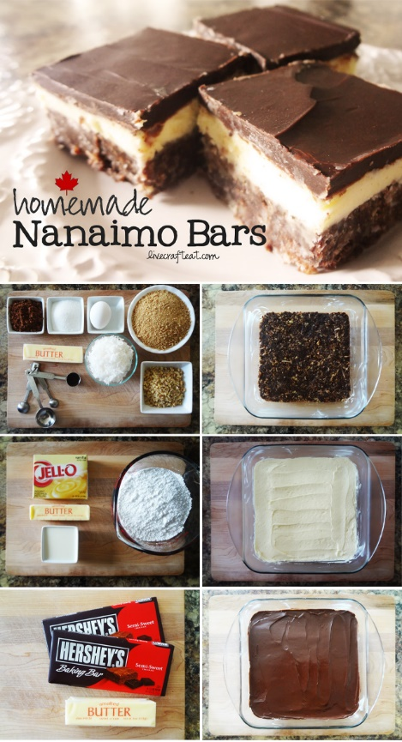½ cup butter

¼ cup sugar

5 tablespoons cocoa powder

1 egg, lightly beaten

1 teaspoon vanilla

2 cups graham cracker crumbs

1 cup shredded coconut

FILLING:

⅓ cup butter, softened

3 tablespoons custard powder (or vanilla jello pudding powder)

¼ cup milk

3 cups icing sugar, sifted

TOPPING:

8 ounces semisweet chocolate

2 tablespoons butter

Instructions

1. BASE: melt butter in a medium saucepan. Add sugar and cocoa and stir until smooth.
2. Whisk egg with vanilla and stir into butter mixture. Remove from heat - no scrambled eggs here!
3. Stir in graham cracker crumbs, coconut. Press evenly over bottom of a greased 9x9" square pan. Chill for a few minutes in the refrigerator.
4. FILLING: beat butter with wooden spoon until light. Beat in custard powder (or pudding powder) and milk. Gradually beat in sugar. Spread over chilled base and let set in fridge.
5. TOPPING: melt together chocolate and butter; stir until smooth. Spread in an even layer over chilled filling. Store in fridge until chocolate topping begins to harden, about 10 minutes. Score topping into bars - cut into small 1-inch squares before totally solid. If needed, use a hot knife and wipe clean between cuts - otherwise the chocolate will start to crack.