**Chick-fil-A Chicken Nuggets**

**Nugget Ingredients:**

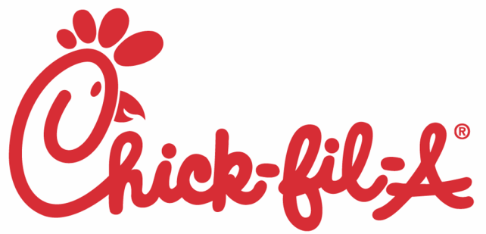2 large chicken breasts, cut into bite-sized pieces and seasoned with salt & pepper  
3/4 cup milk  
1/4 cup pickle juice (optional)   
1 egg  
1-1/4 cups flour  
2 Tablespoons powdered sugar  
2 teaspoons salt  
1 teaspoon pepper  
1/2 cup canola oil, divided (or peanut or vegetable oil)

**Chick-fil-A Sauce:**

1/4 cup mayo

1 tsp. yellow mustard

1/2 tsp lemon juice

1 Tbsp. honey

1/2 Tbsp. smokey BBQ sauce

**Directions:**

1. Whisk together egg, milk and pickle juice, and pour into a large Ziplock bag or bowl. Add chicken pieces and marinate in the refrigerator for 2-4 hours or overnight.
2. Combine flour, powdered sugar, salt and pepper in a large mixing bowl. Stir to combine. Remove chicken from the marinade and cut into bite-sized pieces. After, add to large bowl. Stir chicken in mix to coat completely.
3. Heat half the oil (1/4 cup) in a large skillet or Dutch oven over medium-high heat. Test the oil by dropping in a bit of the flour mixture. If it sizzles, the oil is ready, if it pops, lower the temperature a bit.
4. Gently place chicken pieces into the oil with tongs. Do this in 2 batches, as you don’t want to overcrowd the pan. Cook the chicken for 3-4 minutes, or until golden brown on one side. Turn the chicken over and allow to cook for 3-4 more minutes. Remove to a paper-towel lined plate. Heat the remaining oil and continue with the other half of the chicken pieces.
5. Stir together the Chick-fil-A dipping sauce ingredients, and serve with the hot chicken bites.