**Pumpkin Cake Bars**

[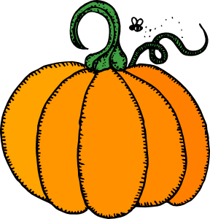](javascript:edit(2055))Yields: About 16 cake bars

***Ingredients:***

**For the cake:**

* 1 (15 ounce) can pumpkin puree
* 2/3 cup low-fat Greek yogurt
* 1 teaspoon vanilla extract
* 2 eggs
* 1 teaspoon baking soda
* 1 cup white sugar
* 3 teaspoons baking powder
* 2 cups all-purpose flour
* 1/2 teaspoon of salt
* 2 teaspoons pumpkin pie spice
* Cooking spray

**For the frosting:**

* 5 ounces light cream cheese
* 1 cup powdered sugar
* 1 teaspoon vanilla
* 1/4 cup toasted almonds, chopped (optional)

***Directions:***

1. To make the cake: Preheat oven to 350 degrees F. Grease an 8 x 8-inch glass cake plate with cooking spray.
2. Separate egg whites in custard cup. Mix pumpkin, yogurt, vanilla, egg whites and sugar well in a large mixing bowl. Once combined, add in baking soda, baking powder, flour, salt and pumpkin pie spice until fully mixed (once flour disappears).
3. Bake for about 30 minutes, or until cake comes out dry when inserted with a toothpick.
4. To make the frosting: Mix cream cheese, powdered sugar and vanilla together. Once cake has cooled, frost and garnish with toasted almonds.