Soil Formation Worksheet
Soil is a mixture of weathered rock & organic matter that usually covers bedrock (solid rock that underlies all soil). Both chemical & mechanical processes are involved in the development of soils.
- Chemical weathering turns hard minerals into soft ones
- Mechanical weathering breaks solid rock into smaller pieces
- Plant & animals add organic materials in the form of waste products & dead organisms
- The decay of organic matter produces acids which accelerate chemical weathering
- Burrowing Animals, such as earthworms, insects, & rodents, help circulate air and water through the soil & mix mineral & organic remains

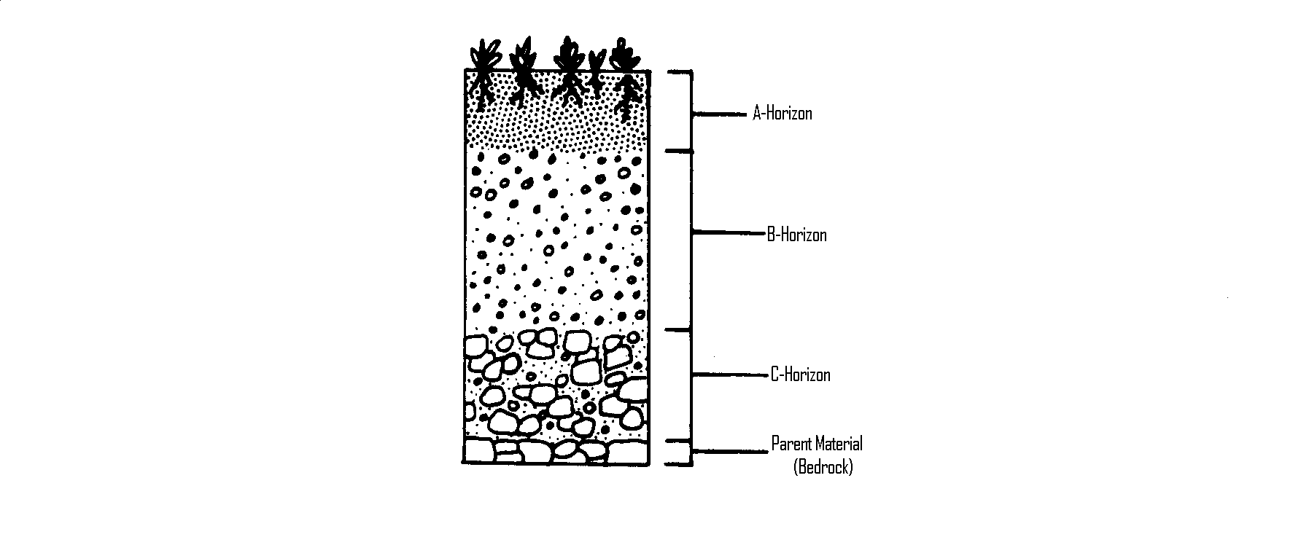
The material from which soil forms is called its parent material. Soil that has weathered directly from the bedrock beneath it and therefore matches its parent material is called residual soil.

Soil that does not match the bedrock it is over is called transported soil. It did not weather from the bedrock beneath it but was brought there by agents of erosion such as winds, rivers, or glaciers. Much of New England & the Midwest are covered by soil that was deposited by the movement of glaciers after the last Ice Age.

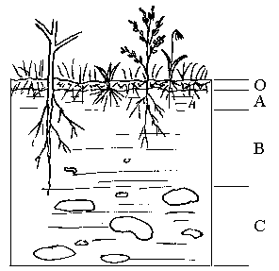
A cross section of soil exposed by digging is called the soil profile. The weathering of soil produces layers known as soil horizons. The topsoil or A horizon is usually rich in dark-colored organic remains called humus (labeled O horizon below). The subsoil or B horizon contains minerals that have been transported deeper by groundwater. Most of the clay in soil has also been washed down to this layer. The partially weathered bedrock or C horizon is composed of broken up bedrock on top of the solid bedrock (parent material).

Soil erosion is the removal of topsoil by the action of running water or wind. It takes between 100 & 400 years for one centimeter of topsoil to form.

Loss of topsoil can be caused when plants root are no longer present to hold down soil. Salting roads can raise the salinity of the soil and kill the plants. Over grazing can kill plants. Winds construction, & mining can all effect plant cover.
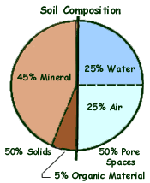
Means of soil conservation include the following:
- Windbreaks – belts of trees along the edge of fields
- Contour farming – crops are planted in rows parallel to land contours p143
- Terraces- flattening hill slopes to slow the flow of water & erosion
- Strip Cropping – a crop that leaves bare ground between rows is alternated with a crop that completely covers the ground, ex. Corn & Alfalfa
- No-till method- plowing, planting and fertilizing are all done at the same time so there is less chance of wind removing topsoil

Use the worksheet above to answer the following questions.

_____ 1. Which layer in the diagram below contains the most organic material?
A. A B.B C.C D. the bedrock

_____ 2. How is soil created from rock?
- physical weathering without chemical weathering
- chemical weathering without physical weathering
- erosion without weathering
- weathering without erosion

_____ 3. Which of the soil conservation methods is least used in NJ?
A. Strip Cropping C. Terraces
B. Windbreaks D. no-till method

_____ 4. Approximately how many years does one centimeter of topsoil take
to form?
A. 100 – 400 years C. 1000 – 4000 years
B. 10 – 40 years D. 10,000 – 40,000 years

_____ 5. Which of the following is found in the greatest % in soil?
A. Mineral matter B. Organic matter C. Water D. Air

_____ 6. Which layer of a soil profile forms first from the bedrock?
A. A horizon B. B horizon C. C horizon D. humus

7. For the soil profiles below, label the horizons (A, B, or C) and the parent material
in each of the soil profiles using the spaces provided next to each image.
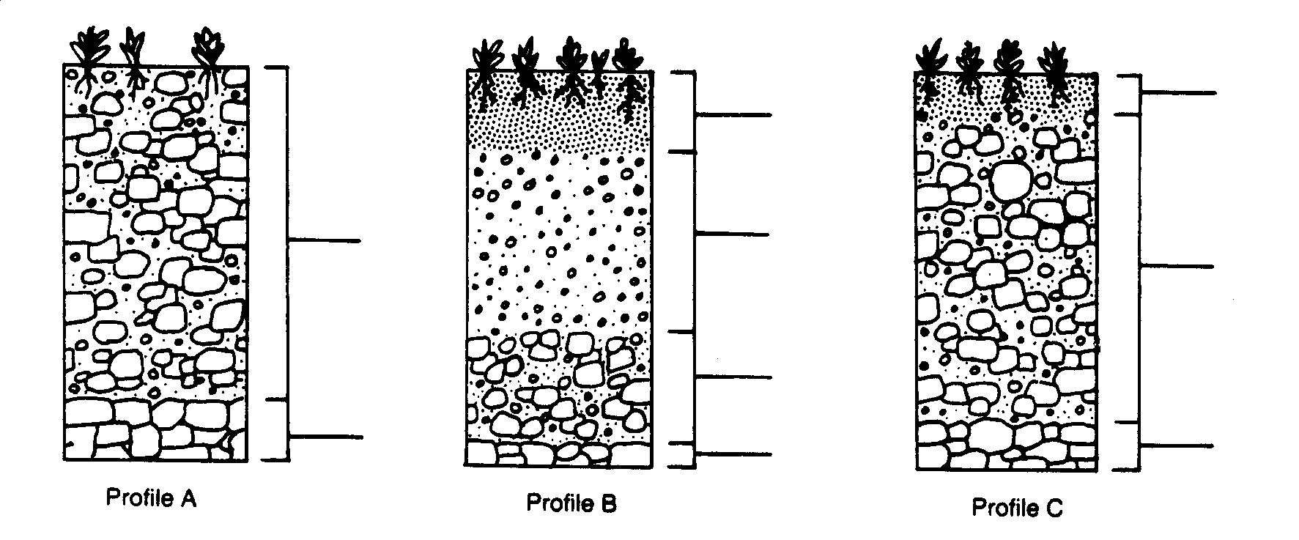
______ ______ ______

8. At the base of each profile above, number the profiles according to the proper
sequence of development.

9. Match each soil profile above to the graph below that would most likely represent
that profile. Write the letter of the matching profile in the space provided below each
graph.

