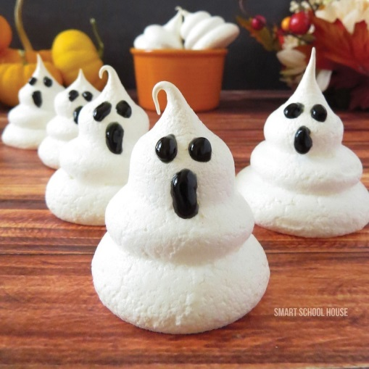
Ghost Meringues

Ingredients
- 4 Egg Whites
- 1/2 tsp. Cream of Tartar
- 1 cup of Sugar
- Black Decorating Icing Gel
Instructions
- Preheat oven to 225 degrees.
- Using an electric mixer, whip the egg whites for a few minutes on high speed until they become frothy (you will see lots of little bubbles).
- Next, add your sugar in small amounts at a time.
- Finally, mix in the cream of tartar.
- Continue to whip the mixture until it gets stiff (meaning that it holds a shape when stopped).
- Prepare your baking sheet with a layer of foil covered with non-stick spray.
- Place the meringue mixture into an icing bag.
- Using your icing bag and a large round icing tip, continually press the meringue mixture directly down onto the foil. Press down and lift up to create layered stacks for each ghost (release the pressure just a tiny bit, pulling up on your frosting bag at the same time in between each layer).
- Bake them for about 45 minutes or until the tops become a little brown.
- Once they are completely cooled, they will harden and be ready to decorate with black gel frosting!
- Add eyes and mouths to your ghost (or create silly faces!).
- Store in an air tight container.
Meringue Tips
- Be sure to use a metal or glass bowl. Plastic won’t work.
- Try not to get any yolk into the egg white- the meringue won’t créate.
- Have eggs at room temp. Before starting.
- Toast in a turned-off oven for an additional 10-15 mins. for a nice crispy texture!

Meringue Demonstration
- Meringues require only egg whites. To get this amount you should:
    - Crack eggs ________ at a time, and allow __________to fall into custard cup. Make sure they are at _______________. Transfer egg whites to kitchen aid mixing bowl and repeat process.
    - If you get __________in the egg whites, throw them out and start over.
- Recipes will direct you to beat egg whites to one of three stages: _________, ____________,________________.

- The meringue recipe first requires you to beat eggs to the ____________ stage. This will appear as bubbles or foam on the surface. At this point add in the flavoring agents.

- Continue beating until the _____________stage: egg whites stand up in the form of a peak, but the tip bends over.

- You must reach this stage _________you add the sugar!!

- Add the sugar a tablespoon at a time and continue beating until the __________stage.

- At the stiff peak stage, the egg whites are full of volume and stand up in the form of a peak. They do not bend!

